Ex 6.12
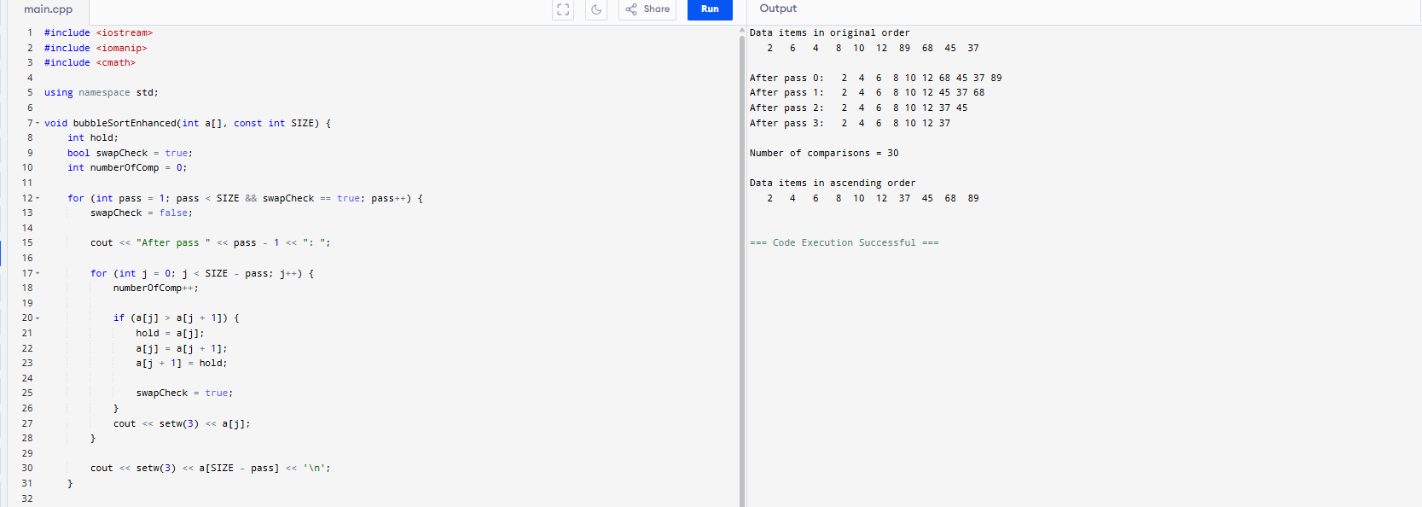
#include <iostream>
#include <iomanip>
#include <cmath>

using namespace std;

void bubbleSortEnhanced(int a[], const int SIZE) {
int hold;
bool swapCheck = true;
int numberOfComp = 0;

for (int pass = 1; pass < SIZE && swapCheck == true; pass++) {
swapCheck = false;

cout << "After pass " << pass - 1 << ": ";

for (int j = 0; j < SIZE - pass; j++) {
numberOfComp++;

if (a[j] > a[j + 1]) {
hold = a[j];
a[j] = a[j + 1];
a[j + 1] = hold;

swapCheck = true;
}
cout << setw(3) << a[j];
}

cout << setw(3) << a[SIZE - pass] << '\n';
}

cout << "\nNumber of comparisons = " << numberOfComp << endl;
}

int main() {
const int SIZE = 10;
// 使用 6.11 題的原始陣列
int a[SIZE] = { 2, 6, 4, 8, 10, 12, 89, 68, 45, 37 };

cout << "Data items in original order\n";
for (int i = 0; i < SIZE; i++) {
cout << setw(4) << a[i];
}
cout << "\n\n";

bubbleSortEnhanced(a, SIZE);

cout << "\nData items in ascending order\n";
for (int q = 0; q < SIZE; q++) {
cout << setw(4) << a[q];
}
cout << endl;

return 0;
}

